- List up to 4 different protocols that appear in the protocol column in the unfiltered packet-listing window.
TCP DNS SNMP HTTP
- How long did it take from when the HTTP GET message was sent until the HTTP OK reply was received?
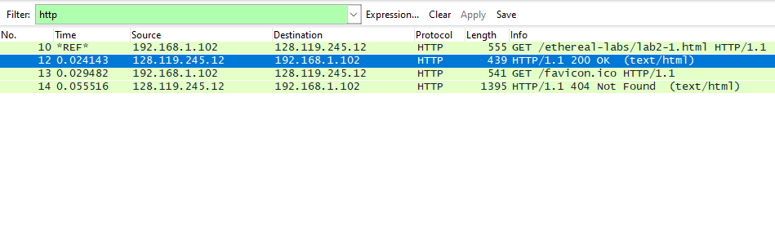
0.024143
- Was the second Get Request successful? How can you tell it from the corresponding response packet?
No
404 Not Found

By looking at the information in the HTTP GET and Response Messages for BOTH the HTTP Requests, answer the following questions
- Is your browser running HTTP version 1.0 or 1.1? What version of HTTP is the server running?
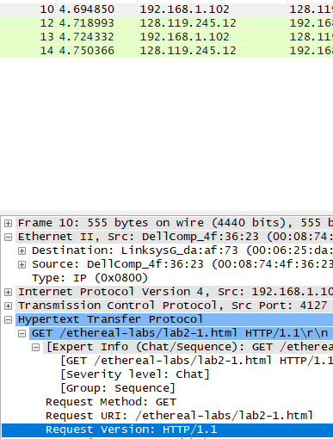
It is 1.1
- What languages (if any) does your browser indicate that it can accept to the server?
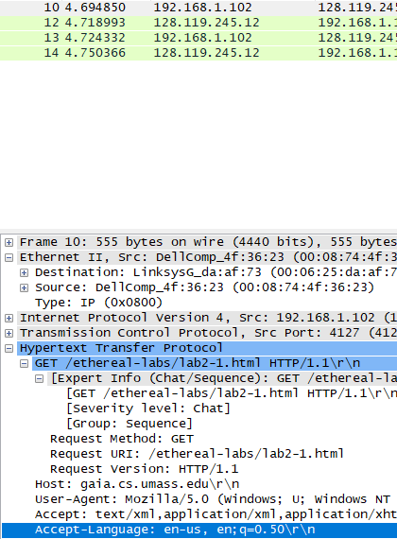
en-us, en
- What is the IP address of the gaia.cs.umass.edu server and your computer?
Server IP address : 128.119.245.12
Computer IP address : 192.168.1.102
- What is the MAC address of the server and your computer?
Server MAC address : Address: LinksysG_da:af:73 (00:06:25:da:af:73)
Computer MAC address : Address: DellComp_4f:36:23 (00:08:74:4f:36:23)
- What is sending and receiving Port Number? What does Port No. 80 represents?
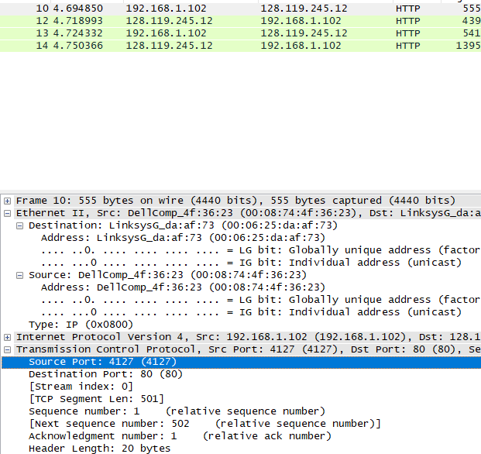
Sending Port : Source Port: 4127 (4127)
Receiving Port : Destination Port: 80 (80)
- What is the status code returned from the server to your browser?
Status Code: 200
Response Phrase: OK
- When was the HTML file, that you are retrieving, last modified at the server?
Last-Modified: Tue, 23 Sep 2003 05:29:00 GMT\r\n
- How many bytes of total packet content are being returned to your browser?

Frame 12: 439 bytes on wire (3512 bits), 439 bytes captured (3512 bits)
The HTTP CONDITIONAL GET/response interaction
Use the http-ethereal-trace-2 packet trace to answer the questions below and apply the “http” filter
Answer the following questions:
- Inspect the contents of the first HTTP GET request from your browser to the server. Do you see an “IF-MODIFIED-SINCE” line in the HTTP GET?
No
- Inspect the contents of the server response. Did the server explicitly return the contents of the file? How can you tell from the Packet Bytes Window?
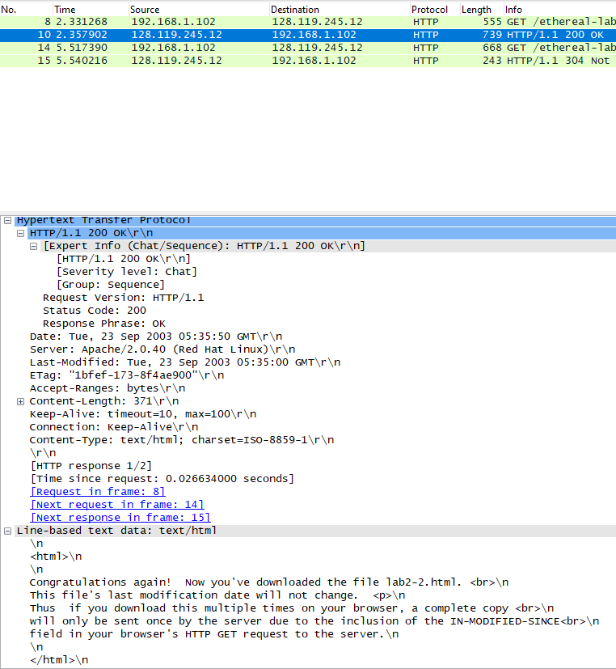
- Now inspect the contents of the second HTTP GET request from your browser to the server. Do you see an “IF-MODIFIED-SINCE:” line in the HTTP GET? If so, what information follows the “IF-MODIFIED-SINCE:” header? What is meant by this information?
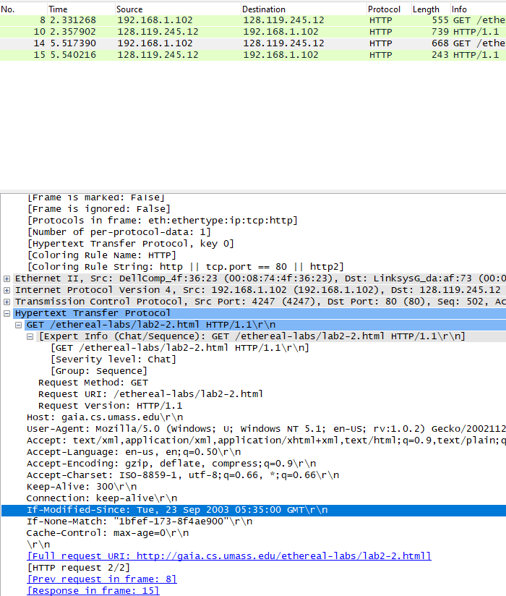
If-Modified-Since means that if the page was modified after provided date and time then the computer will send request to server to resend the current page
- What is the HTTP status code and phrase returned from the server in response to this second HTTP GET? Did the server explicitly return the contents of the file? Explain your answer
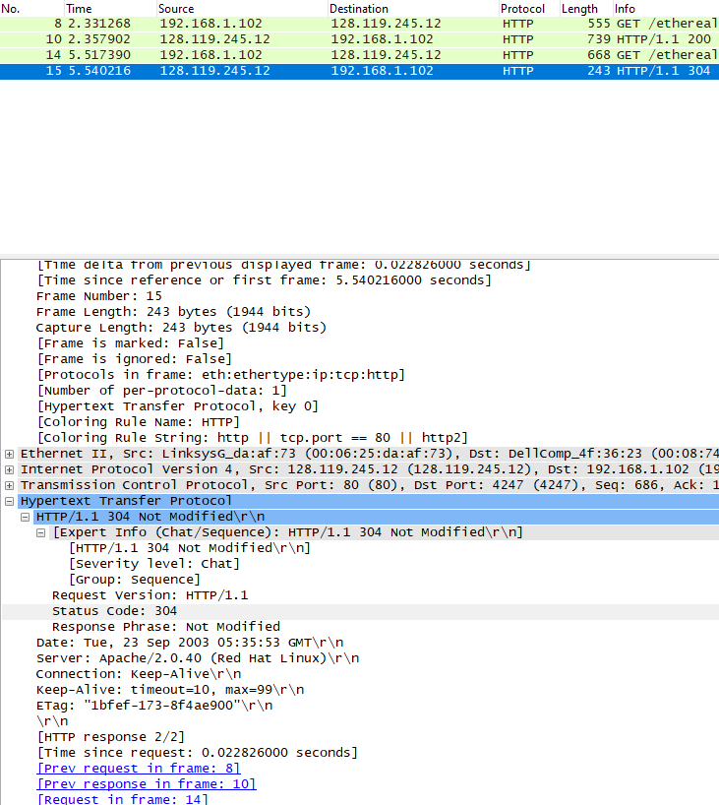
Status Code: 304
Response Phrase: Not Modified
the server explicitly return the contents of the file as the cache had the latest page

In-Lab Statement 2 : Analyzing HTTP Protocol (10)
Retrieving Long Documents
In our examples thus far, the documents retrieved have been simple and short HTML files. Let’s next see what happens when we download a long HTML file. Do the following:
In the packet-listing window, you should see your HTTP GET message, followed by a multiple-packet TCP response to your HTTP GET request. This multiple-packet response deserves a bit of explanation. The HTTP RESPONSE MESSAGE consists of a status line, followed by header lines, followed by a blank line, followed by the entity body. In the case of our HTTP GET, the entity body in the response is the entire requested HTML file. In our case here, the HTML file is rather long, and at 4500 bytes is too large to fit in one TCP packet. The single HTTP response message is thus broken into several pieces by TCP, with each piece being contained within a separate TCP segment. In recent versions of Wireshark, Wireshark indicates each TCP segment as a separate packet, and the fact that the single HTTP response was fragmented across multiple TCP packets is indicated by the “TCP segment of a reassembled PDU” in the Info column of the Wireshark display.
- Use the http-ethereal-trace-3 packet trace to answer the questions below and apply the “http” filter
Answer the following questions:
- How many HTTP GET request messages did your browser send?
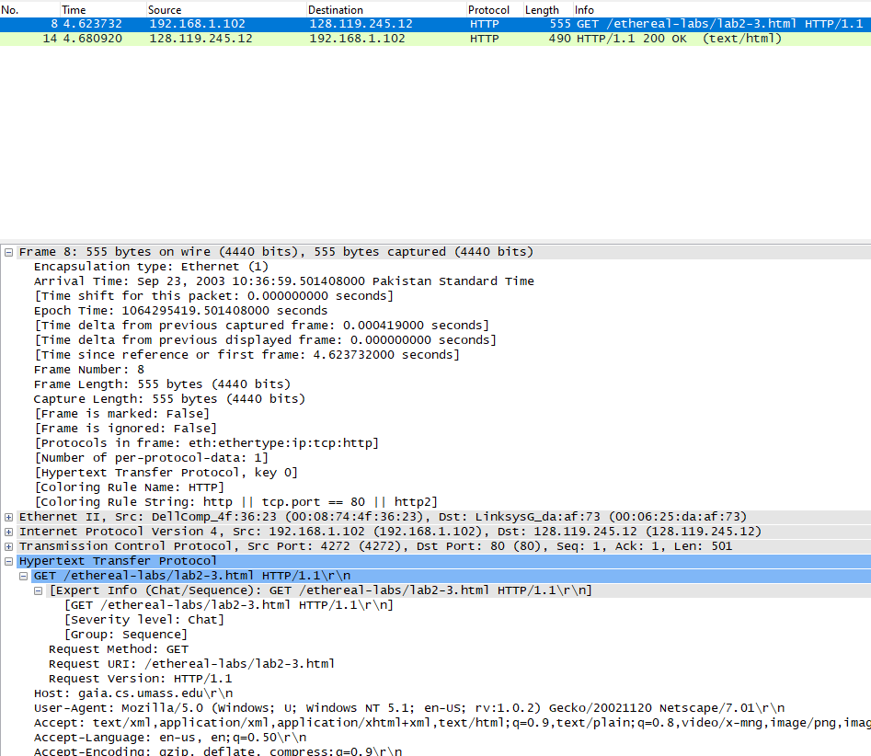
1
- Which packet number in the trace contains the GET message for The Bill of Rights?
8
- Which packet number in the trace contains the status code and phrase associated with the response to the HTTP GET request?
14
- What is the status code and phrase in the response?
200 OK
- How many data-containing TCP segments were needed to carry the single HTTP response and the text of the Bill of Rights? What are the numbers of those packets?
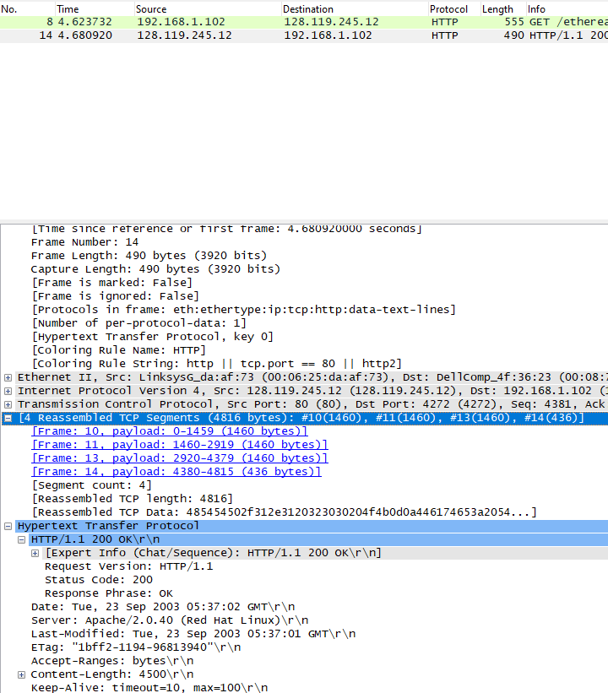
4 Reassembled TCP Segments (4816 bytes): #10(1460), #11(1460), #13(1460), #14(436)
The TCP responses are equal length.

In-Lab Statement 3: Trick Question
What is the length of the text for The Bill of Rights in bytes? How do you justify this length of text when your Response Packet Size is only 490 bytes? Give complete explanation how the length of text in various packets add up to a total of 4500 Bytes.

The HTTP headers seem to be 316 bytes
TCP segments 1460 bytes each + 54 bytes (14 eth + 20 IP + 20 TCP) = 1514 bytes
Frame 14 from last TCP segment 436 bytes + 54 bytes = 490 bytes
So the total length of the bill of rights is longer than 4500 (1514*3) since many headers combined.

